|  |  |
| --- | --- |
| CB.EN.U4CSE20414 | DASARI HARSHAVARDHAN REDDY |
| CB.EN.U4CSE20450 | PUSARLA TARUN VAMSI |
| CB.EN.U4CSE20413 | CHINTHAKUNTA GOWTHAMI REDDY |
| CB.EN.U4CSE20419 | GANAPATHI GUNDAPANENI |
| CB.EN.U4CSE20430 | KILPARAPU REETHIKANJALI |

19CSE102- C PROGRAMMING

GROUP PROJECT

Mobile Number Directory Management

**STUDENT DETAILS:**

**PROBLEM STATEMENT:**

Purpose:

To manage mobile directories across the state efficiently.

Data Collection:

Contact Name

House Name

Locality Name

District Name

Service Provider

Mobile Number

Problem Statement:

To create a mobile directory management system with entries to include information such as Contact Name, House Name, Locality Name, District Name, Service Provider, Mobile Number.

**Functionalities**:

**Adding Customer Details**

Create 6 different elements in structure for contact name, house name, locality, district, service provider and mobile number.

**Data Validation**

* Mobile Number should be 10 digits exactly
* Contact Name should contain only alphabets
* Service provider should be from Airtel, Vi, Jio and BSNL

**Searching**

* Finding customer name from mobile number
* List of customers that use the same service provider
* Finding mobile number from the name of customer

**Update Details**

* Change in Service Provider – Mobile Number Porting
* Change in House name, Locality and District
* Adding a new number for an existing customer

Reports

* Details of a particular customer
* Percentage of mobile numbers in a given district for each service provider
* Percentage of each service provider in existing customers

C CODE:

#include <stdio.h>

#include <string.h>

#include <ctype.h>

struct directory{

char c_name[30];

char hs_name[30];

char locality[30]; //STRUCTURE DECLARATION

char dist[30];

char s_pr[30];

long long int phone_no;

}details[200];

struct space{

char dup_name[30];

};

//NAME VALIDATION FUNCTION

int valid_name(char *dup)

{

int j,flag=1;

j = strlen(dup);

for(int i=0;i<j;i++)

{

if(!(isalpha(*(dup+i)) || isspace(*(dup+i))))

{

flag=0;

break;

}

}

if(!flag)

{

printf("\nEnter the valid details and make sure that \nname should contain only alphabets...\n\n");

}

return(flag);

}

//SERVICE VALIDATION

int valid_sevice(char *dup)

{

int flag=0;

if(!strcmp(dup,"JIO"))

{

flag=1;

}

else if(!strcmp(dup,"BSNL"))

{

flag=1;

}

else if(!strcmp(dup,"VI"))

{

flag=1;

}

else if(!strcmp(dup,"AIRTEL"))

{

flag=1;

}

else

{

printf("\nEnter the valid service providers shown in the list...\n\n");

}

return (flag);

}

//PHONE NUMBER VALIDATION

int valid_ph_no(long long int dup)

{

int count=0,flag=1;

while(dup!=0)

{

dup=dup/10;

count++; //Counting number of digits

}

if(count!=10)

{

flag=0;

printf("\nEnter the valid 10 digit phone number....\n\n");

return(flag);

}

else if(count==10)

{

return(flag);

}

}

//ADD CUSTOMER FUNCTION

void Add_customer(struct directory details[],int max_size,int sz) //FUNCTION DEFINITION(Add_customer)

{

int k,j;

printf("%d\n",sz);

printf("Enter the details\n");

do{

printf("Customer Name: ");

scanf(" %[^\n]s",details[sz].c_name); //ADDING CUSTOMER

k = valid_name(details[sz].c_name);

}while(!k);

do{

printf("\nHouse Name: ");

scanf(" %[^\n]s",details[sz].hs_name);

k = valid_name(details[sz].hs_name);

}while(!k);

do{

printf("\nLocality: ");

scanf(" %[^\n]s",details[sz].locality);

k = valid_name(details[sz].locality);

}while(!k);

do{

printf("\nDistrict: ");

scanf(" %[^\n]s",details[sz].dist);

j=0;

while (details[sz].dist[j]!='\0')

{

details[sz].dist[j]=toupper(details[sz].dist[j]);

j++;

}

k = valid_name(details[sz].dist);

}while(!k);

//printf("\n%s\n",details[sz].dist);

do{

printf("Our Service Providers are:\n1.AIRTEL\n2.VI\n3.JIO\n4.BSNL\n Choose and Enter any of the service providers from above list:\n");

scanf(" %[^\n]s",details[sz].s_pr );

j=0;

while (details[sz].s_pr[j]!='\0')

{

details[sz].s_pr[j]=toupper(details[sz].s_pr[j]);

j++;

}

//printf("%s\n",details[sz].s_pr);

k = valid_sevice(details[sz].s_pr);

}while(!k);

do{

printf("Mobile Number: ");

scanf("%lld",&details[sz].phone_no);

k = valid_ph_no(details[sz].phone_no);

}while(!k);

printf(" ............................................\n\t\t\t\t\t\tYou have succesfully registered with us \n\n\t\t\t\t\t\t\t\tTHANK YOU\n ............................................." );

printf("\n\n\n\n\t\t\t\t\t\t\t\tUPDATED LIST\n");

printf("\n\nName\t\t\t\tHouse Name\t\tLocality\t\tDistrict\t Service Provider\tPhone no.\n");

printf(".......................................................................................................................................\n");

for(int i=0;i<=sz;i++)

{

printf("%s\t%s\t\t%s\t%s\t\t%s\t\t%lld\n",details[i].c_name,details[i].hs_name,details[i].locality,details[i].dist,details[i].s_pr,details[i].phone_no);

}

}

//REMOVE SPACE FUNCTION

int remove_space(struct directory details[],int size1,char *s) //remove_space FUNCTION DEFINITION

{

struct space dup[size1];

int j,fl=0;

for(j=0;j<size1;j++)

{

int i=strlen(details[j].c_name);

int flag=1;

while(flag)

{

if(isalpha(details[j].c_name[i-1])) //REMOVING RIGHT SPACES

{

flag=0;

}

i--;

}

for(int k=0;k<=i;k++)

{

dup[j].dup_name[k]=details[j].c_name[k];

}

dup[j].dup_name[i+1]='\0';

if(!strcmp(dup[j].dup_name,s))

{ //COMPARING THE GIVEN STRING WITH THE CUSTOMER NAME

fl=j;

break;

}

}

return ( fl );

}

//SEARCHING FUNCTION

void searching(struct directory details[],int size) //FUNCTION DEFINITION(SEARCHING)

{

int ch,flag=0,size1,i;

long long int ph_no;

do

{

printf("\nEnter the Respective choice: \n");

printf("\n1.Name of customer via Mobile Number\n2.list of customers of a particular service provider\n3.Mobile Number of customer given a Name\n4.To exit from the function\n\n");

scanf("%d",&ch);

if(ch==1)

{

printf("Enter Mobile Number: "); //SEARCHING FOR A CUSTOMER VIA MOBILE NUMBER

scanf("%lld",&ph_no);

for(i=0;i<size;i++)

{

if(ph_no==details[i].phone_no)

{

size1=i;

flag=1;

break;

}

}

if(flag==1)

printf("\n\nName of the customer is: %s\n\n",details[size1].c_name);

else if(flag==0)

printf("\nEntered Mobile number has not registered with us................\n\n");

}

else if(ch==2)

{

int j=0;

char service[10];

printf("\nEnter service provider: ");

scanf("%s",service);

while (service[j]!='\0') //SEARCHING FOR A LIST OF CUSTOMERS OF A PARTICULAR SERVICE PROVIDER

{

service[j]=toupper(service[j]);

j++;

}

printf("\n\nName\t\t\t\tHouse Name\t\tLocality\t\tDistrict\t Service Provider\t\tPhone no.\n");

printf("...............................................................................................................................................................\n");

for(i=0;i<size;i++)

{

if(!strcmp(service,details[i].s_pr))

{

printf("%s\t%s\t\t%s\t%s\t\t %s\t\t \t%lld\n\n",details[i].c_name,details[i].hs_name,details[i].locality,details[i].dist,details[i].s_pr,details[i].phone_no);

}

}

}

else if(ch==3)

{ //SEARCHING FOR A MOBILE NUMBER VIA NAME OF THE CUSTOMER

int k;

char name[30];

printf("Enter name: ");

scanf(" %[^\n]",name);

k = remove_space(details,size,name); //CALLING THE remove_space function

if(k)

printf("\nPhone Number of the customer is: %lld\n\n",details[k].phone_no);

else if(k==0)

printf("\nEntered Customer Name has not registered with us................\n\n");

}

}while(ch!=4);

}

//UPDATE DETAILS FUNCTION

void update_details(struct directory details[],int size)

{

int ch,i,j,k,size1,flag=0;

char dup[50];

long long int ph_no;

do{

printf("\nEnter the Respective choice: \n");

printf("\n1.change service provider(Mobile Number Porting)\n2.Change in House name,Locality and District\n3.Adding a new number for an existing customer\n4.To exit from the function\n\n");

scanf("%d",&ch);

if(ch==1)

{

do{

printf("Enter Mobile Number of the Customer to change the details: "); //SEARCHING FOR A CUSTOMER VIA MOBILE NUMBER

scanf("%lld",&ph_no);

k = valid_ph_no(ph_no);

}while(!k);

for(i=0;i<size;i++)

{

if(ph_no==details[i].phone_no)

{

size1=i;

flag=1;

break;

}

}

if(flag==1)

{

printf("\nCustomer Name: %s\n\nYour current service provider is %s...\n\n",details[size1].c_name,details[size1].s_pr);

strcpy(dup,details[size1].s_pr);

}

do{

printf("Our Service Providers are:\n1.AIRTEL\n2.VI\n3.JIO\n4.BSNL\n Choose and Enter any of the service providers from above list:\n");

scanf(" %[^\n]s",details[size1].s_pr );

j=0;

while (details[size1].s_pr[j]!='\0')

{

details[size1].s_pr[j]=toupper(details[size1].s_pr[j]);

j++;

}

//printf("%s\n",details[size1].s_pr);

k = valid_sevice(details[size1].s_pr);

if(!strcmp(dup,details[size1].s_pr))

{

printf("\nDont enter the existing service provider \nEnter the service provider you want to port\n\n");

k=0;

}

}while(!k);

printf("\nYour new service provider is %s\n",details[size1].s_pr);

printf("\nYour service provider has been succesfully changed\n\n");

printf("Thank you\n\n");

}

else if(ch==2)

{

flag=0;

do{

printf("Enter Mobile Number of the Customer to change the details: "); //SEARCHING FOR A CUSTOMER VIA MOBILE NUMBER

scanf("%lld",&ph_no);

k = valid_ph_no(ph_no);

}while(!k);

for(i=0;i<size;i++)

{

if(ph_no==details[i].phone_no)

{

size1=i;

flag=1;

break;

}

}

if(flag==1)

{

printf("\n......................................................................................\n");

printf("\nExisting details of the customer are: \n");

printf("\nCustomer Name : %s\nHouse Name : %s\nLocality : %s\nDistrict : %s\n",details[size1].c_name,details[size1].hs_name,details[size1].locality,details[size1].dist);

printf("\n......................................................................................\n");

}

do{

printf("\nHouse Name: ");

scanf(" %[^\n]s",details[size1].hs_name);

k = valid_name(details[size1].hs_name);

}while(!k);

do{

printf("\nLocality: ");

scanf(" %[^\n]s",details[size1].locality);

k = valid_name(details[size1].locality);

}while(!k);

do{

printf("\nDistrict: ");

scanf(" %[^\n]s",details[size1].dist);

j=0;

while (details[size1].dist[j]!='\0')

{

details[size1].dist[j]=toupper(details[size1].dist[j]);

j++;

}

k = valid_name(details[size1].dist);

}while(!k);

printf("\n......................................................................................\n");

printf("\nUpdated details of the customer are: \n");

printf("\nCustomer Name : %s\nHouse Name : %s\nLocality : %s\nDistrict : %s\n",details[size1].c_name,details[size1].hs_name,details[size1].locality,details[size1].dist);

printf("\n......................................................................................\n");

}

else if(ch==3)

{

flag=0;

do{

printf("Enter old Mobile Number of the Customer to change to new mobile Number: "); //SEARCHING FOR A CUSTOMER VIA MOBILE NUMBER

scanf("%lld",&ph_no);

k = valid_ph_no(ph_no);

}while(!k);

for(i=0;i<size;i++)

{

if(ph_no==details[i].phone_no)

{

size1=i;

flag=1;

break;

}

}

if(flag==1)

{

printf("\n......................................................................................\n");

printf("\nCustomer Name: %s\n",details[size1].c_name);

printf("\nExisting Mobile Number of the customer is: %lld\n",details[size1].phone_no);

printf("\n......................................................................................\n\n");

printf("Enter new Mobile Number of the Customer: ");

scanf("%lld",&details[size1].phone_no);

printf("\n\n......................................................................................\n");

printf("\nCustomer Name: %s\n",details[size1].c_name);

printf("\nUpdated(new) Mobile Number of the customer is: %lld\n",details[size1].phone_no);

printf("\n......................................................................................\n");

}

else if(flag==0)

{

printf("\nEntered Mobile number has not registered with us................\n\n");

}

}

}while(ch!=4);

}

//REPORT FUNCTION

void reports(struct directory details[],int size)

{

int ch,flag=0,size1,i,k;

long long int ph_no;

char s[30];

do

{

printf("\nEnter the Respective choice: \n");

printf("\n1.Full details of a customer provided his number\n2.Percentage of people using each service provider in a district\n3.Percentage of each service provider\n4.Exit from reports\n");

scanf("%d",&ch);

if(ch==1)

{

do{

printf("Enter Mobile Number of the Customer to find the details: "); //SEARCHING FOR A CUSTOMER VIA MOBILE NUMBER

scanf("%lld",&ph_no);

k = valid_ph_no(ph_no);

}while(!k);

for(i=0;i<size;i++)

{

if(ph_no==details[i].phone_no)

{

size1=i;

flag=1;

break;

}

}

if(flag==1)

{

printf("\n......................................................................................\n");

printf("\nCustomer Name : %s\nHouse Name : %s\nLocality : %s\nDistrict : %s\nService Provider: %s\nPhone Number : %lld\n",details[size1].c_name,details[size1].hs_name,details[size1].locality,details[size1].dist,details[size1].s_pr,details[size1].phone_no);

printf("\n......................................................................................\n");

}

else if(flag==0)

printf("\nEntered Mobile number has not registered with us................\n\n");

}

else if(ch==2)

{

int j=0,b=0,a=0,v=0,flag=0,p;

float tot;

do{

p=0;

printf("Enter name of the district to get percentage of mobile numbers of each Service Provder: ");

scanf(" %[^\n]s",s);

while (s[p]!='\0')

{

s[p]=toupper(s[p]);

p++;

}

k = valid_name(s);

//printf("%s\n",s);

}while(!k);

printf("\n\nName\t\t\t\tDistrict\t Service Provider\n");

printf("......................................................................................\n");

for(i=0;i<size;i++)

{

if(!strcmp(details[i].dist,s))

{

flag=1;

printf("%s\t\t%s\t\t %s\t\t\n\n",details[i].c_name,details[i].dist,details[i].s_pr);

if(!strcmp(details[i].s_pr,"JIO"))

{

j=j+1;

}

else if(!strcmp(details[i].s_pr,"BSNL"))

{

b=b+1;

}

else if(!strcmp(details[i].s_pr,"AIRTEL"))

{

a=a+1;

}

else if(!strcmp(details[i].s_pr,"VI"))

{

v=v+1;

}

}

}

if(flag==0)

{

printf("\nThere are no customers in the district: %s.......\n",s);

}

else if(flag==1)

{

tot=j+b+a+v;

printf("Total number of JIO customers are: %d\n\nTotal number of BSNL customers are: %d\n\nTotal number of AIRTEL customers are: %d\n\nTotal number of VI customers are: %d\n\n",j,b,a,v);

printf("\n......................................................................................\n\n");

printf("Percentage of people using JIO : %.1f percent\nPercentage of people using AIRTEL: %.1f percent\nPercentage of people using VI : %.1f percent\nPercentage of people using BSNL : %.1f percent\n",(j*100)/tot,(a*100)/tot,(v*100)/tot,(b*100)/tot);

printf("\n......................................................................................\n");

}

}

else if(ch==3)

{

int j=0,b=0,a=0,v=0,flag=0,p;

float tot;

for(i=0;i<size;i++)

{

if(!strcmp(details[i].s_pr,"JIO"))

{

j=j+1;

}

else if(!strcmp(details[i].s_pr,"BSNL"))

{

b=b+1;

}

else if(!strcmp(details[i].s_pr,"AIRTEL"))

{

a=a+1;

}

else if(!strcmp(details[i].s_pr,"VI"))

{

v=v+1;

}

}

tot=j+b+a+v;

printf("Total number of JIO customers are: %d\n\nTotal number of BSNL customers are: %d\n\nTotal number of AIRTEL customers are: %d\n\nTotal number of VI customers are: %d\n\n",j,b,a,v);

printf("\n......................................................................................\n\n");

printf("Percentage of people using JIO : %.1f percent\nPercentage of people using AIRTEL: %.1f percent\nPercentage of people using VI : %.1f percent\nPercentage of people using BSNL : %.1f percent\n",(j*100)/tot,(a*100)/tot,(v*100)/tot,(b*100)/tot);

printf("\n......................................................................................\n");

if((j>b&&j>a)&&j>v)

{

printf("\nJIO has highest number of Customers....\n");

}

else if((b>j&&b>a)&&b>v)

{

printf("\nBSNL has highest number of Customers....\n");

}

else if((a>j&&a>b)&&a>v)

{

printf("\nAIRTEL has highest number of Customers....\n");

}

else

{

printf("\nVI has highest number of Customers....\n");

}

}

}while(ch!=4);

}

//MAIN FUNCTION

int main()

{

int choice;

int size=50;

struct directory details[50]

= { { "Tanmay Hirawat ","The Cottage ","Rajendra Nagar ","ANANTAPUR", "AIRTEL", 9848193160},

{ "Varenya Guthikonda ","Rose Cottage ","RC Nagar ","CHITTOOR", "JIO", 9491081950},

{ "Hemanth Saketh Rayaprolu","The Bungalow ","Ashok Nagar ","EAST GODAVARI", "BSNL", 9581717788},

{ "Yashnav ","The lodge ","Vimla Nagar ","ANANTAPUR", "VI", 8978844887},

{ "Venkat ","Wood lands ","Kamla Nagar ","EAST GODAVARI", "JIO", 7093429161},

{ "Aditya ","Old school ","Vishal Nagar ","ANANTAPUR", "AIRTEL", 9848195260},

{ "Samhita ","Ivy Cottage ","TC Nagar ","CHITTOOR", "VI", 9484081950},

{ "Ananaya ","The Villow ","Gandhi Nagar ","VISAKHAPATNAM", "BSNL", 7581717788},

{ "Yashnav ","The lodge ","Vimla Nagar ","ANANTAPUR", "AIRTEL", 8978844887},

{ "Aryan ","Wood lands ","TC Nagar ","EAST GODAVARI", "JIO", 7993429161},

{ "Radha Hirawat ","The Cottage ","Rajendra Nagar ","ANANTAPUR", "AIRTEL", 9848793160},

{ "Vanshika ","Rose Cottage ","RC Nagar ","CHITTOOR", "BSNL", 9491081850},

{ "Lakshmi ","The Bran ","Lakshmi Nagar ","HAKIMPUR", "BSNL", 9381717788},

{ "Utkar singh ","The croft ","Shalini Nagar ","VIZIANAGRAM", "AIRTEL", 7978844887},

{ "Venkat singh ","Wood hill ","Sai Nagar ","HAKIMPUR", "JIO", 7193429161},

{ "Nirma ","Old Vicrage ","Vishal Complex ","EAST GODAVARI", "AIRTEL", 9748195260},

{ "Latha ","Ivory Cottage ","TC Colony ","HAKIMPUR", "VI", 9564081950},

{ "Sai ","Sun Shide ","Police Barracks ","LAKHIMPUR", "BSNL", 7382717788},

{ "Keerthana ","River lodge ","Vimla Colony ","VIZIANAGRAM", "JIO", 8988844887},

{ "Aryan singh ","Top lands ","KC Nagar ","EAST GODAVARI", "JIO", 7999429161},

{ "Varma ","The Knook ","Bank Colony ","ANANTAPUR", "AIRTEL", 9848193790},

{ "Baggam ","Rose Block ","RC Colony ","CHITTOOR", "JIO", 9491081930},

{ "Harini ","Fair View ","Ashok Nagar ","EAST GODAVARI", "BSNL", 9581717768},

{ "Srinivas ","Mill House ","Vimla Nagar ","ANANTAPUR", "VI", 8978844547},

{ "Manoj ","Corner lands ","shaamla Nagar ","VIZIANAGRAM", "JIO", 7093429321},

{ "Satya ","Way side ","Trishal Nagar ","ANANTAPUR", "AIRTEL", 9848195269},

{ "Raja ","White House ","TC Nagar ","CHITTOOR", "VI", 9484081958},

{ "Srikanth ","Tree Villow ","Gandhi Nagar ","VISAKHAPATNAM", "BSNL", 7581717786},

{ "Raju ","Wood lands ","KV Nagar ","EAST GODAVARI", "JIO", 7993429131},

{ "Rajesh ","Wood Oaks ","Kamla Nagar ","ANANTAPUR", "JIO", 6993429831},

{ "Deepthi ","The Villa ","Rajendra Nagar ","ANANTAPUR", "AIRTEL", 9848792160},

{ "Swetha ","Rose Heaven ","RC Nagar ","CHITTOOR", "BSNL", 9491081650},

{ "Poorna ","The Cottage ","Army Colony ","ANANTAPUR", "BSNL", 9381717888},

{ "Kalpana ","The Frizz ","Shalini Nagar ","EAST GODAVARI", "VI", 7978844447},

{ "Rajani ","Wood Heaven ","Sai Nagar ","VISAKHAPATNAM", "JIO", 7193429761},

{ "Vinilla ","Old Heaven ","Vidhya Complex ","VIZIANAGRAM", "AIRTEL", 9748195360},

{ "Sridevi ","Ivory School ","TC Complex ","EAST GODAVARI", "VI", 9564081850},

{ "Sangeetha ","Sun Shade ","Police Barracks ","LAKHIMPUR", "BSNL", 7382717488},

{ "Pavithra ","River School ","Nehuru Colony ","HAKIMPUR", "JIO", 8988854887},

{ "Sirisha ","Top View ","KLC Nagar ","EAST GODAVARI", "JIO", 7999429341},

{ "Uday ","The Hill ","Rajendra Nagar ","ANANTAPUR", "AIRTEL", 9848792179},

{ "Rajeshwari ","Hill Heaven ","RC Nagar ","CHITTOOR", "BSNL", 9491081432},

{ "Anjana ","The Tops ","Army Colony ","ANANTAPUR", "BSNL", 9381917988},

{ "Sunitha ","The Orchards ","Shalini Nagar ","VIZIANAGRAM", "AIRTEL", 7978544447},

{ "Kalyani ","Wood Falls ","Sai Nagar ","EAST GODAVARI", "JIO", 7193426761},

{ "Neelima ","Mill House ","Vidhya Complex ","VISAKHAPATNAM", "AIRTEL", 9748195389},

{ "Mythri ","Oak House ","TC Complex ","VIZIANAGRAM", "VI", 9564081850},

{ "Assema ","Sun Oaks ","Police Barracks ","LAKHIMPUR", "BSNL", 7383417488},

{ "Lavanya ","River Fields ","Nehuru Colony ","EAST GODAVARI", "JIO", 8943354887},

{ "Sukidevi ","Top Oaks ","Windcent Colony ","HAKIMPUR", "JIO", 7999428741}

};

printf("\n\n");

printf("\t\t\t\t\t\t ..............................\n");

printf("\t\t\t\t\t\t\t!EXISTING CUSTOMER DETAILS!\n");

printf("\t\t\t\t\t\t ..............................\n");

printf("\n\nName\t\t\t\tHouse Name\t\tLocality\t\tDistrict\t Service Provider\tPhone no.\n");

printf(".......................................................................................................................................\n");

//PRINTING EXISTING CUSTOMERS

for(int i=0;i<50;i++)

{

printf("%s\t%s\t\t%s\t%s\t\t%s\t\t%lld\n",details[i].c_name,details[i].hs_name,details[i].locality,details[i].dist,details[i].s_pr,details[i].phone_no);

}

printf("\n\n");

printf("\t\t\t\t\t ................................................\n");

printf("\t\t\t\t\t\t!WELCOME TO MOBILE DIRECTORY MANAGEMENT!\n");

printf("\t\t\t\t\t ................................................\n");

do

{

printf("\nEnter the respective choice: \n");

printf("\n1.Register as a New Customer\n2.Search for Details of Customer\n3.Update Details\n4.For Reports\n5.Exit Application\n\n");

scanf("%d",&choice);

if(choice==1)

{

Add_customer(details,200,size); //CHOICE 1

size++;

continue;

}

else if(choice==2)

{

searching(details,size); //CHOICE 2

continue;

}

else if(choice==3)

{

update_details(details,size); //CHOICE 3

continue;

}

else if(choice==4)

{

reports(details,size); //CHOICE 4

continue;

}

}while(choice!=5);

printf("Thank You\n");

return 0;

}

**OUTPUTS:**

**STORING 50 CUSTOMER DETAILS**

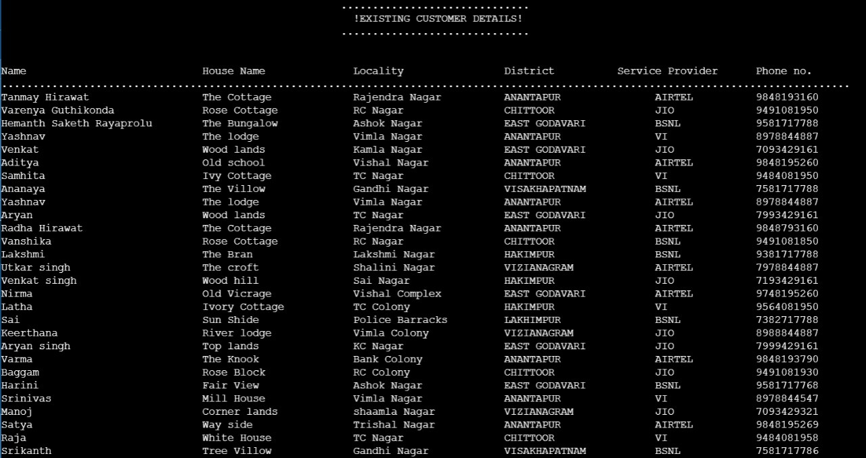

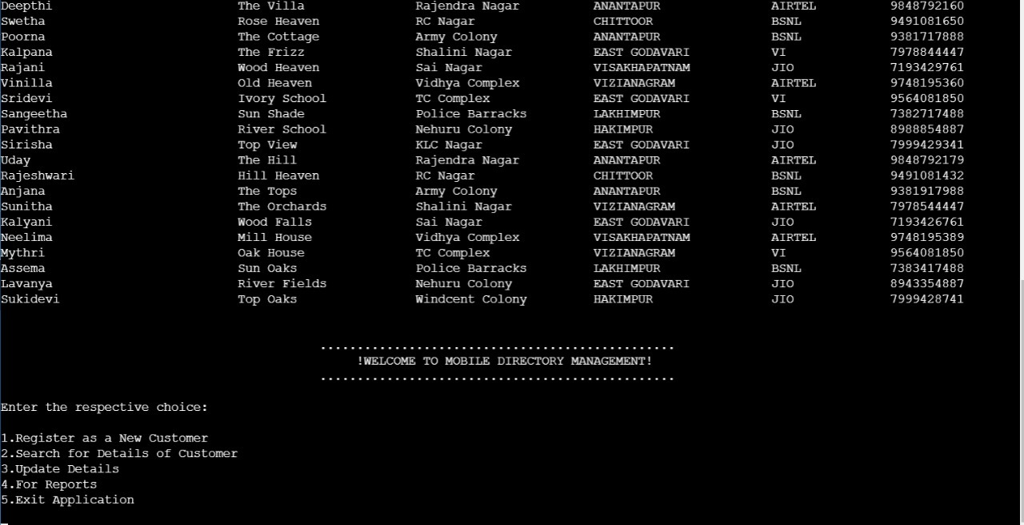

**ADDING NEW CUSTOMER:**

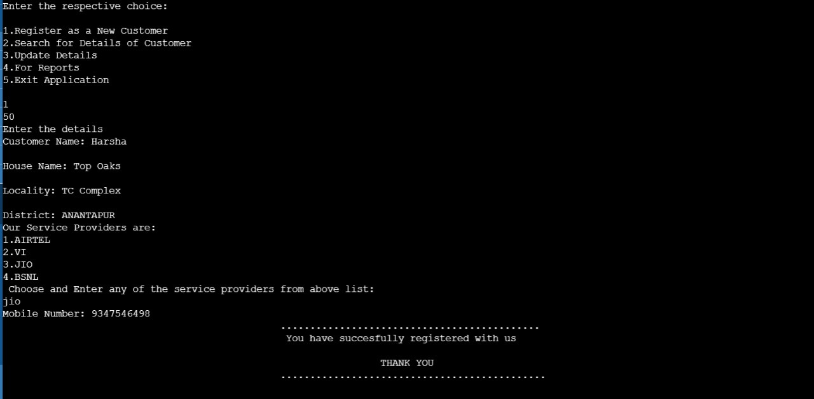

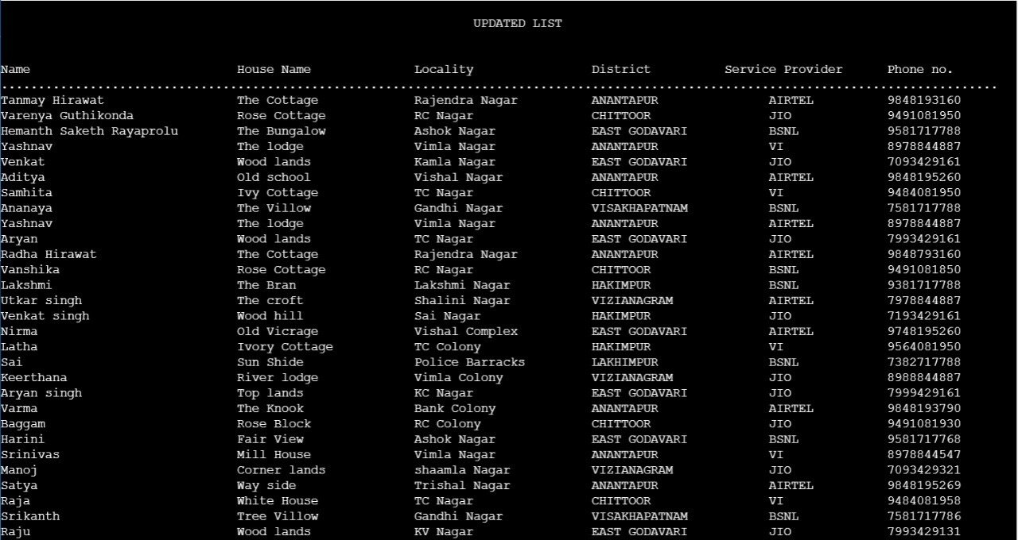 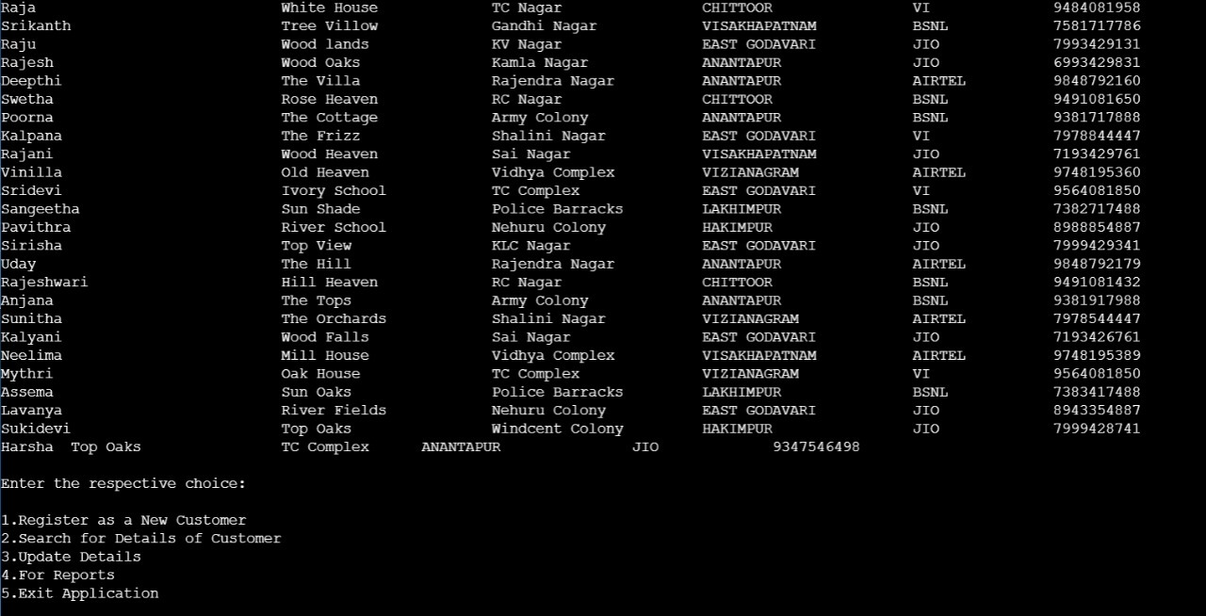

**SEARCHING:**

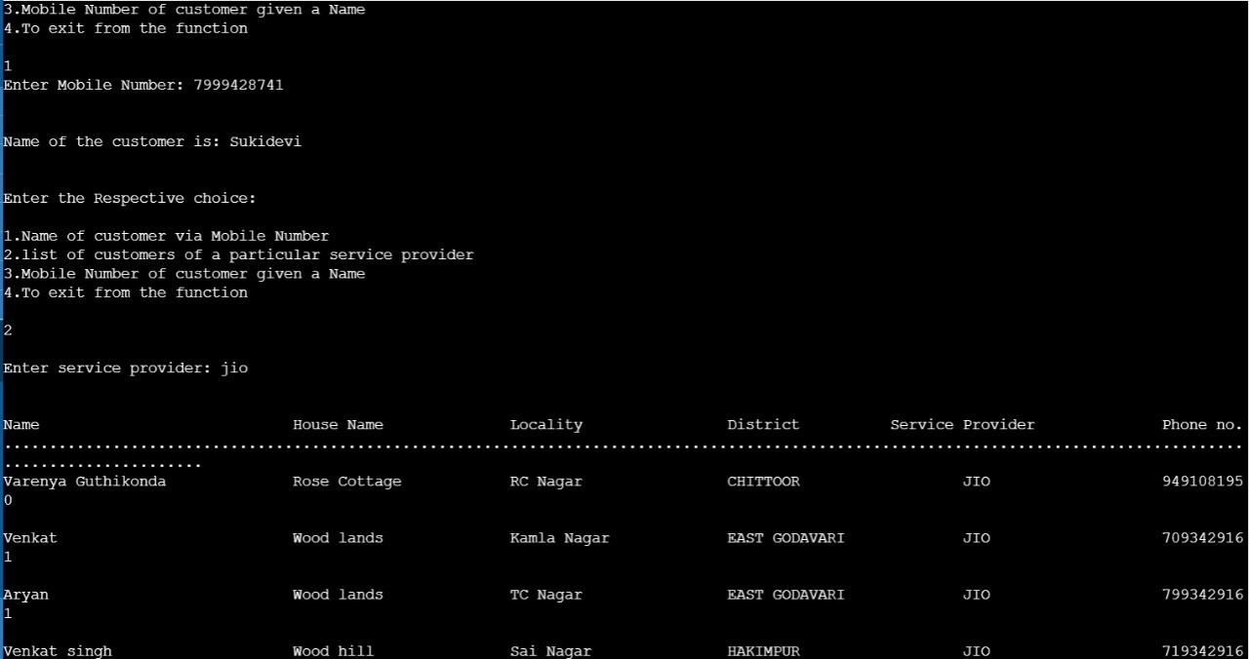

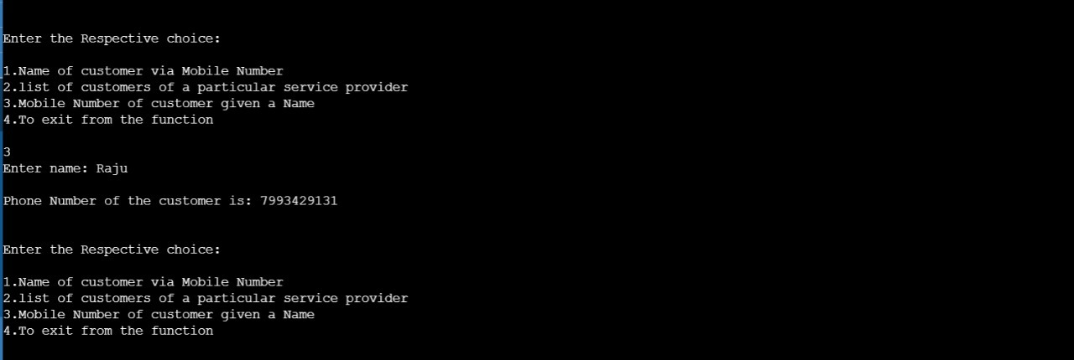

**UPDATE DETAILS:**

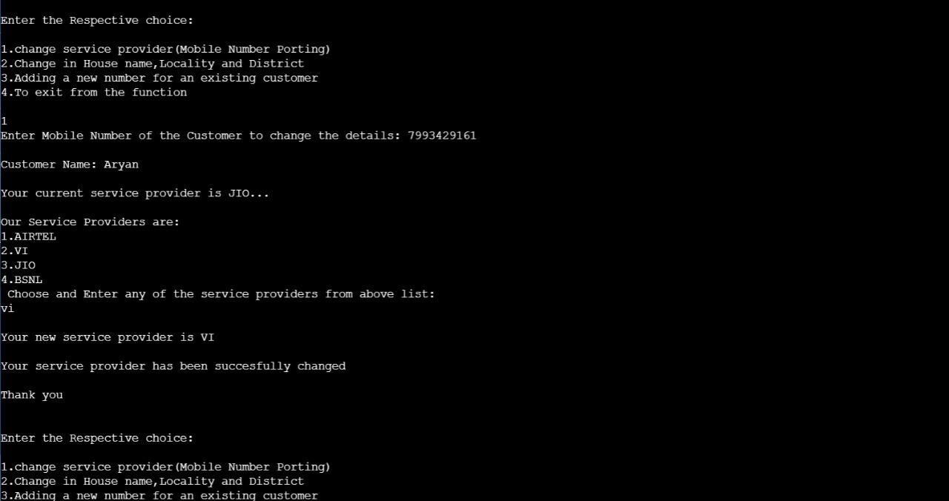

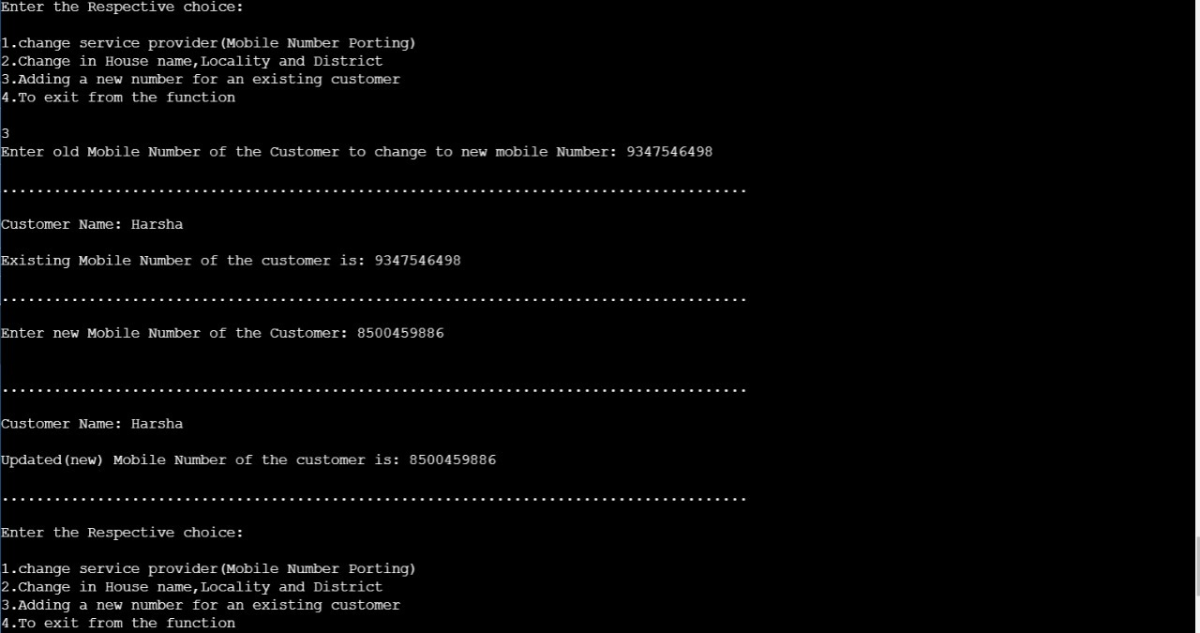

**REPORTS:** 